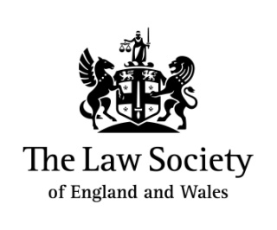 | 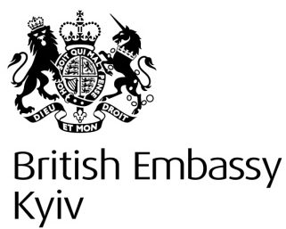 |  | 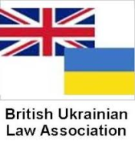
The Law Society of England and Wales, the
British Embassy Kyiv, the Ukrainian National Bar Association and the British-Ukrainian Law Association

request the pleasure of your company at their

English Law Day Forum in Kyiv

Thursday 23 March 2016, 10:30 - 19:30
(registration from 09:30)

Venue: Radisson Blu Hotel Kyiv, Yaroslaviv Val Str. 22, Kyiv 01054, Ukraine

Recent positive changes in the regulatory framework and business environment in Ukraine, which facilitate the ease of setting up a business in Ukraine, establish an excellent basis for trade between the United Kingdom and Ukraine and provide a great opportunity to explore opportunities in this market.

The preferred choice of English Law as the governing law in contracts, and status of England and Wales as a global legal centre make it important for business and their advisers to have advanced knowledge of English law and how transactions and disputes involving Ukrainian parties benefit from a practical understanding of English law principles.

The forum will bring together Ukrainian and UK legal practitioners and business representatives to promote legal links and business between practitioners from both jurisdictions.

A team of leading English and Ukraine practitioners will discuss these topics.

- Private wealth - Protection of assets using off-shore jurisdictions and English Law
- M&A transactions - use of English Law in M&A transactions involving Ukrainian parties
- Dispute resolution - International arbitration and Litigation
- Disputes resolution - asset tracing

The conference is aimed at representatives from leading companies, law firms and organisations from both the UK, Ukraine and Central Asia. The working language for this event is English.
The seminar will be followed by a networking reception
Registration for this event is free, please RSVP with your name, job title and company details to Iryna Kuguk, Iryna.Kuguk@fco.gov.uk.

Draft programme
Venue: Radisson Blu Hotel Kyiv, Yaroslaviv Val Str. 22, Kyiv 01054, Ukraine

09:30 - 10:30 | Registration and refreshments
10:30 - 11:00 | Welcome remarks and introductions  - Representative from the Law Society  - Representative from the British Embassy in Kyiv (tbc)  - Representative from the Ukrainian National Bar Association (tbc)  - Representative from the British Ukrainian Law Association (tbc)
11:00 - 12:00 | Private wealth - protection of assets using off-shore jurisdictions and English Law and consequences  - Offshore and English Law related consequences  - Using offshore entities for corporate structuring  - top levels of holding structures – use of English or offshore trusts or alternatives  - Uses and abuses of the PSC register  - Family law implications - benefits and risk of England and Wales  - relevant considerations subject to English law for Ukrainian nationals who spend time/have assets/have businesses in the UK  - relevant immigration law provisions  - relevant tax law provisions  - relevant family law provisions  - relevant property law provisions  Moderator: to be confirmed  Panel members:  - Dominic Prentis, Partner, Gowling WLG, London  - Izzy Walsh, Associate, Dawson Cornwall, London  - Dmitry Zapol, International Tax Advisor, International Fiscal Services Limited, London
12:00 - 12:30 | Tea and coffee break
12:30 - 13:30 | M&A transactions - use of English Law in M&A transactions involving Ukrainian parties  - A brief road map to cross-border merger transactions  - Why use of English Law in M&A transaction involving Ukrainian parties?: Benefits, consequences and limitations?  - Latest trends in international M&A transactions connected to Ukraine  - Distinguishing features of M&A transactions involving distressed sellers/assets  - M&A transactions involving liquidators/administrators  Moderator: Sergei Ostrovsky, Partner, Ashurst, London  Panel members:  - Anna Babych, Partner, Aequo, Kyiv  - Graham Conlon, Acting Managing Partner, Cameron McKenna LLC, Kyiv
13:30 - 14:30 | Lunch
14:30 - 15:30 | Disputes resolution - international arbitration and Litigation  - International commercial arbitration – overview of latest trends and important developments  - Shareholders disputes & ‘economic divorces’ arising out of challenging conditions  - Conflict of laws between English and Ukrainian law – whose jurisdiction wins?  - Enforcement of Ukrainian arbitral awards and court judgments in England and Wales  - Recognition and enforcement of English arbitral awards and court judgments in Ukraine  - Costs - Third party funding of arbitration disputes: Realisation and constrains - a lawyer's perspective  - Investment arbitration latest news  - New rules and guidance from arbitration institutions - who is the driver of change?  Moderator: Artem Doudko, Counsel, White & Case LLP, London  Panel members:  - Hussein Haeri, Partner and co-Head of International Arbitration, Withers LLP, London  - Andrei Yakovlev, Partner, King & Wood Mallesons LLP, London  - Olena Perepelynska, President, Ukrainian Arbitration Association, and Partner, Integrities law firm, Kyiv  - Noah Rubins, Partner, Freshfields Bruckhaus Deringer LLP, Paris
15:30 - 16:00 | Tea and coffee break
16:00 - 17:00 | Disputes resolution - asset tracing - panel discussion  A moderated discussion involving a Ukrainian lawyer, English lawyer, investigator and forensic expert on how to proceed once you have a money arbitral award or court decision that is not being satisfied voluntarily  - What needs to be done with the award/decision for it to be useable in different jurisdictions as a basis for enforcement purposes  - Identifying, locating and preserving the debtor’s assets - the tricky dance of professionals  - Available court mechanisms to assist with enforcement  - using information about debtor and his/her assets as evidence in enforcement proceedings  Moderator: Iryna Mudra, Head of Restructuring Division at State Savings Bank of Ukraine "Oschadbank"(to be confirmed)  Panel members:  - Olivia Allison, Director in charge of Forensics, KPMG Kyiv (to be confirmed)  - Yuri Botiuk, Partner, Grosvenor Law, London  - Jason Woodland, Partner, Peters & Peters, London  - Vsevolod Volkov, Partner, Integrites Law Firm, Kyiv
17:00 - 17:05 | Closing remarks
17:05 - 19:30 | Networking reception

